**The Royal College of Midwives**

**Leading for Maternity Improvement Course**

**For Band 7 and aspiring Band 7 Midwives**

**What is it?**

The RCM Leading for Maternity Improvement Course is an innovative and transformational four-day development journey for Band 7 Midwives who aspire to develop and apply their leadership skills in a positive and supportive work environment.

The four-day course, which is delivered over six months, will enable participants to gain personal insights and develop practical leadership and management skills to deploy at work. Participants will develop their leadership skills and examine how to put women and families at the heart of what they do.

The programme is based on learning through four key modules:

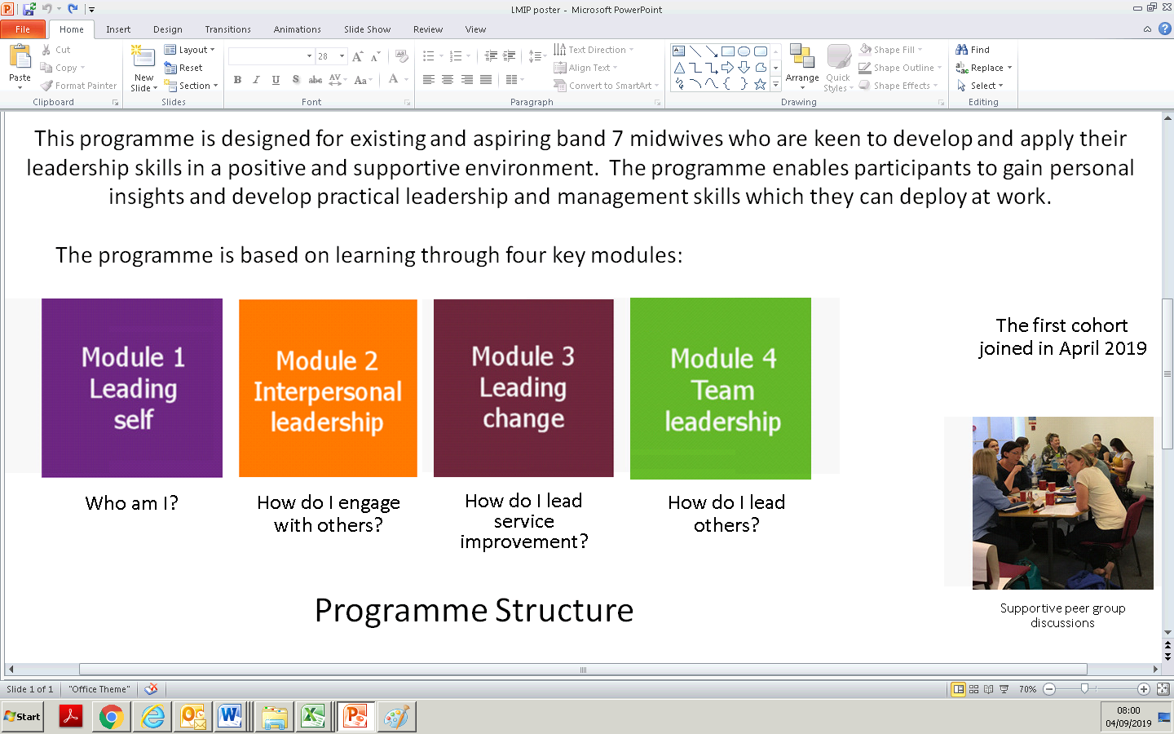

**Programme Structure**

The programme is undertaken over a six-month period, and includes the following elements:

* Attendance at four one-day workshops, the content of which is based on each of the four module themes
* Online activity using i-learn in the form of guided learning prior to each workshop, interaction with a cohort discussion forum, and reflective writing via the RCM’s i-folio platform
* Development of a personal maternity improvement project, with guidance from the course tutors and a workplace mentor
* One-to-one coaching, via either the RCM or a workplace coach, designed to support learners in exploring their wider development beyond the life of the programme
* The opportunity to receive a Certificate of Endorsement or Development from the Institute of Leadership and Management on completion of the programme

**What is the time commitment demanded by the course?**

The Course will require a significant investment of time and energy –

* The self-directed learning will demand approximately 45 hours of you time over the six months of the course
* You will attend four one-day workshops which will require pre workshop preparation
* You will engage in two-hours of coaching
* Your personal project will demand up to 20 hours of your time over the six months of the course

**What are the conditions for registration?**

Places on the course are limited, and you will need to demonstrate that: -

* You have the sponsorship of your Head/Director of Midwifery to attend all four modules of the course and a clear commitment to be released for the four study days;
* You have a thirst for self-development and an aspiration to become a leader within your service;
* You are committed to invest significant time in completion of the self-directed and project-based learning;
* You have identified, and agreed with your Head/Director of Midwifery a service improvement project that you will work on throughout the course
* You have identified a mentor from within your Trust/Health Board with whom you will work throughout the course – your mentor may be a senior Midwife within your Unit or an experienced leader from elsewhere within your Trust/Health Board;

**Course accreditation**

Accredited by The Institute of Leadership & Management and this is included in the cost which is £350 +vat.

**Course dates and venues 2020**

**Chester Grosvenor,** Eastgate Street, Chester, CH1 1LT

04-February 05-March 22-April, 21-May

**AC Hotel by Marriott Belfast,** Belfast Harbour, Donegall Quay, Belfast BT1 3FE

19-February, 19 March, 28 April, 4 June

**Park Regis** 160 Broad Street, Fiveways, Birmingham, B15 1DT

02-September 13-October 04-November 10-December

**How do I apply?**

You must be a RCM Member to join this course and you can book your place through the RCM website <https://www.rcm.org.uk/rcm-events/>. If you have any queries please email [leadershipevents@rcm.org.uk](mailto:leadershipevents@rcm.org.uk)