**How to add or remove a password**

To set a password on your Word or Excel file click File > Info > Protect Document > Encrypt with Password.

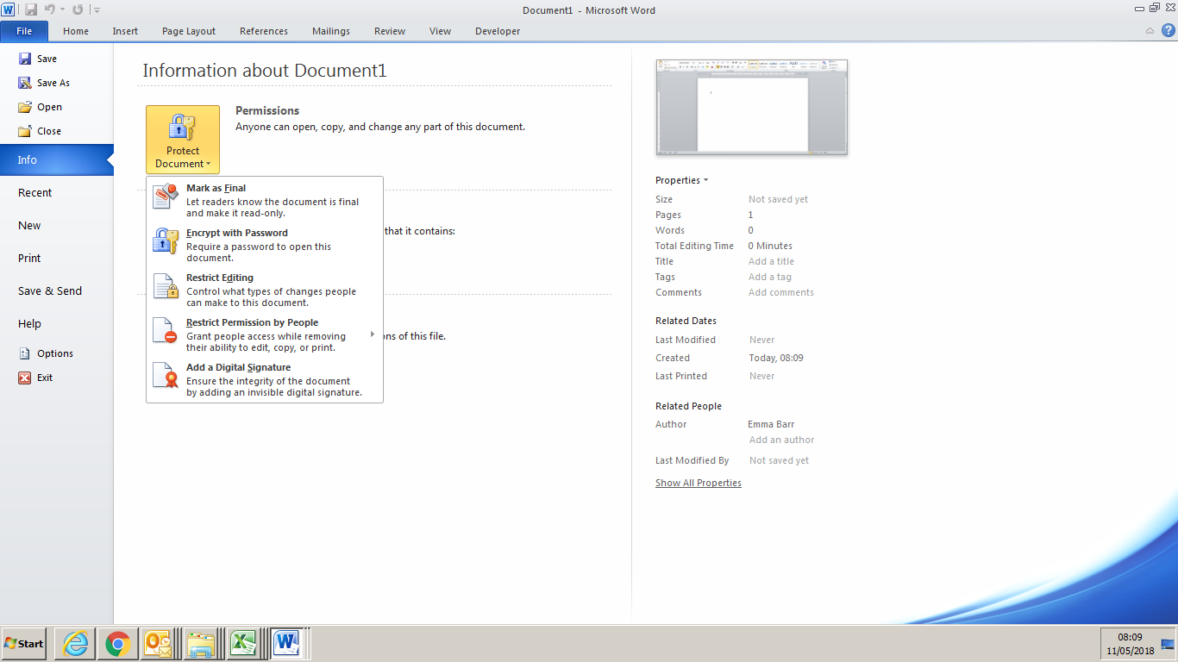

You'll be prompted to create a password, then to confirm it.

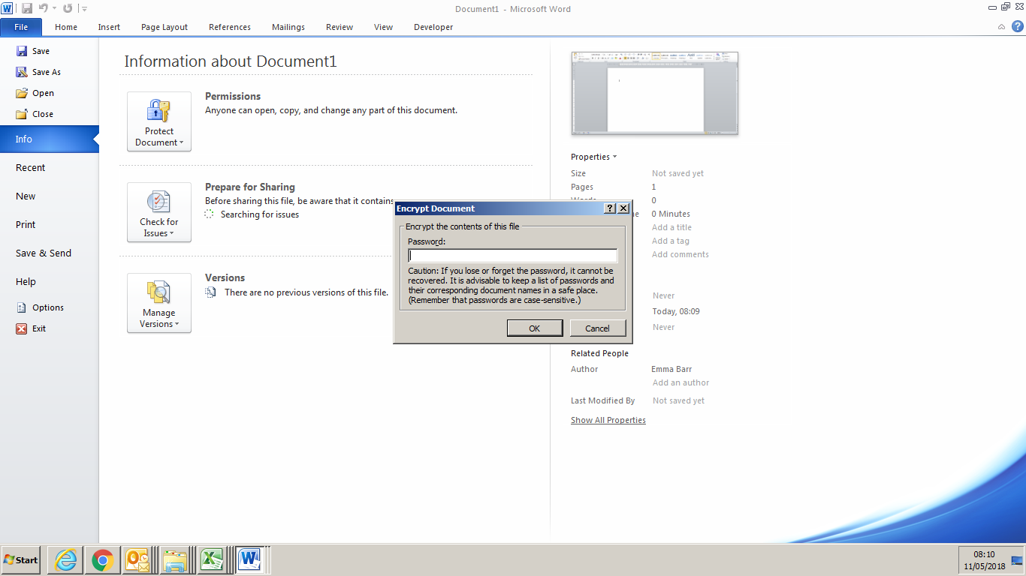

After you've added a password to your file you'll want to be sure to save the file to make sure the password takes effect

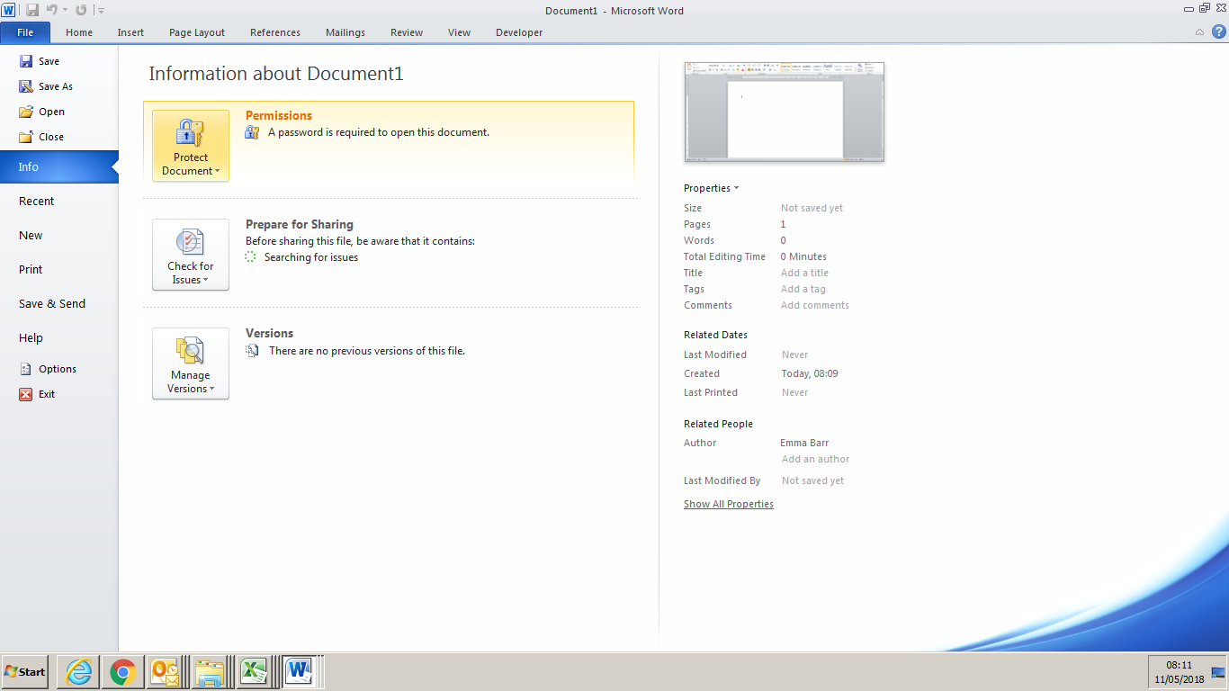.

**Important:**

End Users: Keep your password in a safe place. If you lose or forget the password, it cannot be recovered or removed.

After you've added a password to your file, that password will need to be entered before anybody can open the file.

**To remove the password** open the file, which will require the current password, go to File > Protect Document > Encrypt with Password. Delete the password and click OK. Be sure to save your file to make that change permanent.