**How to BCC on emails**

You should use BCC when sending emails to a group of people this will ensure that emails addresses are not shown to recipients. A good example of this is when emailing Branch members as consent will probably not have be given for this information to be shared.

The RCM highly recommends you set up an email address specifically for your role as an Activist. Never use you a shared email address for this role as sensitive and confidential information can be sent to this email.

To display the Bcc box in Outlook:

* Open a new e-mail message, and then click Options.

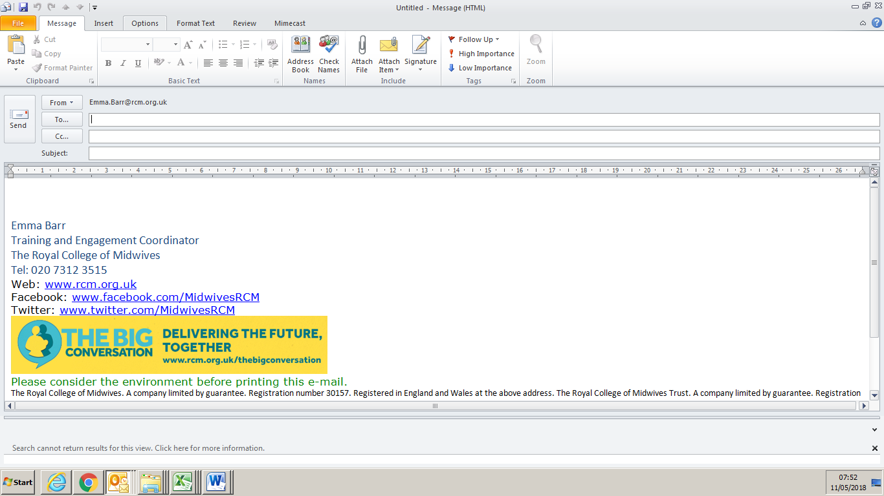

On the Fields area, click Bcc – always put an email address in the To field even if itis i just your own.

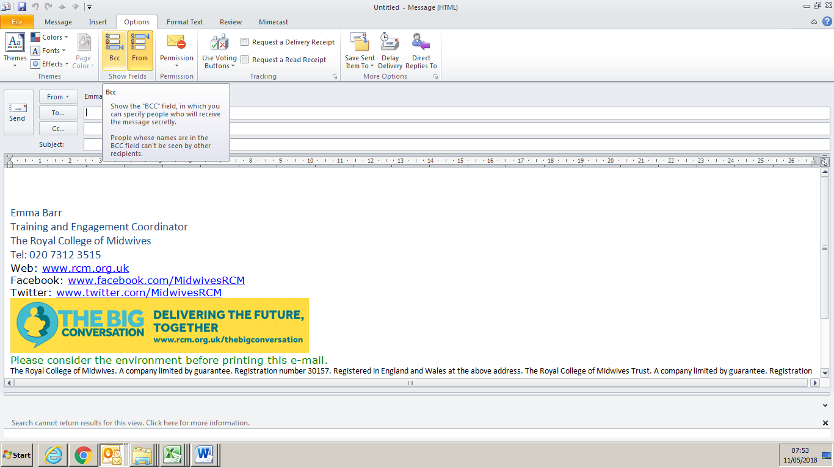

The following example shows how blind carbon copy works.

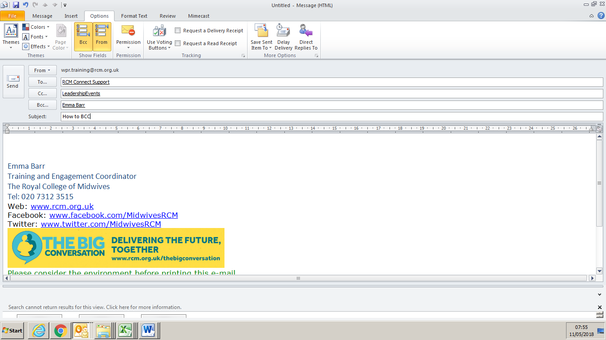

From: wpr.training

To: RCM Connect Support

CC: leadership events

Bcc: Emma Barr

In this example, wpr.training has sent the message to three people: RCM Connect Support, Leadership events and Emma Barr. Message recipients that are listed in the To box are not aware of message recipients that are listed in the Bcc box. In this example, RCM Connect Support and Leadership Events are unaware that Emma has received the message. Message recipients that are listed in the Bcc box are also not aware of each other.